**Pastoralist Resilience: Roles of Customary Institutions in Central Afghanistan**

Chalachew Niguse Agonafir*, International Consultant

*corresponding author: P.O. Box 32638, Addis Ababa, Ethiopia. Email: [chalachewn@gmail.com](mailto:chalachewn@gmail.com), Cellphone: +251 968 583-263

**Abstract:** This paper draws on the findings of a research on the roles of customary institutions in building resilience of pastoralists in Kabul and Parwan Provinces of Central Afghanistan against complex humanitarian misfortunes. The study revealed *malik*, *Jirga* and *shura* contribute in addressing shocks and stresses through managing water/rangelands, conflicts and maintaining the rules and norms, respectively. These institutions encourage pastoralists to take cautionary actions in the face of disasters and promote social support and cooperation that includes all-inclusive mobility, *zeka-*based livestock sharing, delivery of feed during winter, payment for livestock services, construction of flood prevention dams and reporting the situation to the government.

Pastoralists’ resilience is highlighted by unified families regardless of the nature of the shocks and stressors and peaceful coexistence. Efficiency of customary institutions in managing rangelands, mobility and negotiation with neighboring sedentary farmers, adaptation to changes and uncertainties and re-organization of institutions towards ecological sustainability are the factors that indicate resilience of pastoralists in the study area. Pastoralists and elites suggested the need for government and other actors to build the capacity of customary systems at field and policy levels to enhance local microfinances, natural resources management, peaceful pastoral communities and links to market systems.

**Key words**: Central Afghanistan,pastoralists, customary institutions, resilience, ecological sustainability

**Introduction**

Pastoral systems are vital elements in the global socio-economic development strategies. Worldwide, there are over 200 million pastoralists living in harsh and uncertain situations where alternative farming systems are hardly possible (Nori *et al.* 2008; Desta 2009). Livestock reared in pastoral systems contribute significantly to national and regional economies and provide important environmental services such as carbon sequestration, fire prevention, and biodiversity conservation (Nori *et al.* 2008).

About 2.5 million pastoralists (also known as *Kuchi* locally) are believed to inhabit marginalized parts of Afghanistan throughout the country (De Weijer 2007; Tepper 2008). Over 35% of the export earning of Afghanistan comes from pastoralists’ livestock and their outputs which include live animals, meat, leather, cashmere, karakul etc. Conservative estimates put the total landmass suitable for pastoralist at 45% while optimists estimate from 70-85% which has huge potential compared to the largely exploited 12% arable land in Afghanistan (De Weijer 2007).

However, the *Kuchi*/pastoralists in Afghanistan suffer from shocks and stresses associated with extreme insecurity and conflict and natural disasters such as drought, flooding and rampant livestock disease outbreaks. These limit the competence of the sector to contribute to the national economy of the war torn Afghanistan (Desta 2009). Drought incidence from 1999 to 2002 was reported to decimate up to 70 percent of the *Kuchi* livestock (De Weijer 2007).

According to De Weijer (2007) and Desta (2009) the extreme droughts that have been recurring for at least the last 10 years have depressed the *Kuchi*’s ability to recover and maintain their herd. Furthermore, informal conflict management mechanisms and skills to negotiate access to water and pasture have been weakened. As a result, the *Kuchi* system is in a downward spiral of increasing poverty and food insecurity (Desta 2009). Managing pastoral risk is important because it is a major determinant of pastoral poverty, food insecurity and environmental degradation (Desta 2009).

The roles of customary institutions in resilience building in pastoralist areas are well documented in Somalia (Nori *et al*. 2005), Kenya (Robinson 2009), Botswana (Sallu *et al.* 2010), Ethiopia (Elemo 2006 and Yami *et al.* 2011), Mongolia (Baival 2012) and Uzbekistan (Shaumarov and Birner 2013).

It is apparent that customary structures are what sustained populations through decades of conflict and weak governance in Afghanistan. They play significant roles in governance, security, and socio-economic facets of the rural community (Wardak 2003; Saltmarshe and Medhi 2011). This justifies the importance of understanding customary institutions to bridging the gap (Kantor 2009; De Weijer 2013).

Understanding how *Kuchi* communities in Afghanistan were organized and how they traditionally solved issues was fundamental to developing a successful resilience building. Saltmarshe and Medhi (2011) underlined that the success of local governance initiatives in Afghanistan ultimately depends upon how technocratic outsiders are able to navigate the web of customary institutions and actors. Therefore, it is very timely to revitalize appropriate customary systems of *Kuchi* communities in order to salvage their livelihoods from further deterioration (Desta 2009).

So far there are no comprehensive researches endeavored to study how customary institutions function in building resilience of Afghan *Kuchies* against natural and/or man-made shocks and stressors. This research; therefore, identifies customary institutions that involve in building resilience of pastoralists in the Central Afghanistan and the opportunities to incorporate them in development policies and practices.

**Survey Design an Research Methodology**

In this study 153 pastoralists/*Kuchies* and 6 elites/experts were interviewed from Kabul and Parwan Provinces of the central Afghanistan in 2015. Kabul province is Located at Latitude of 34-31' North and Longitude of 69-12’ East. The province entails the capital city of Afghanistan (Kabul) with a total population of 4,227, 261 (CSO 2006). Parwan province is located at latitude of 35o 3’ North and longitude of 68o 55’ East (Orris and Bliss 2002). It is one of the ancient locations in the Hindu Kush Mountains of Afghanistan with total population of 653,362 (CSO 2006). The survey was specifically conducted in 7 villages of Bagrami, Qarabagh and Deh Sabz districts of Kabul and 3 villages of Baghraam district of Parwan Provinces respectively. The districts were selected as *Kuchi* nomads settle in the areas during the study period[1].

The study entails descriptive and explanatory as well as quantitative and qualitative approaches (Walliman 2006). The sample sizes were, pastoralist household survey (n=153) and in-depth key informant interview of elites (n=6). Convenience sampling was used to locate the samples with security and seasonal mobility of the *Kuchi* communities being taken into account (Walliman 2006). The households were selected based on systematic sampling in which every other household was interviewed. For the key informant interview, snowball sampling method was used as per the approach given by Walliman (2006).

The quantitative data were analyzed using descriptive univariate, bivariate and multivariate statistical methods (Walliman 2006). These included tools such as frequency, ranking, histograms, and chi-square. Generally, the findings of the qualitative information obtained from the household survey as well as the elites’ perspective were used to analyze and build on the quantitative findings.

**Results and Discussion**

***Livelihood Strategies of Pastoralists in Kabul and Parwan***

In this study, a household survey of 86 and 67 pastoralists of *Pashtun* ethnicity conducted in Kabul and Parwan Provinces respectively. Further, 6 elites were involved in key informant interview. In relation to the level of mobility, experts/elites highlighted that there are 3 types of pastoralists in Afghanistan – mobile, semi-settled and settled pastoralists. This agrees with the findings of De Weijer (2005) and Tepper (2008) that highlights mobility between different countries, between provinces of Afghanistan and agro-pastoralists. Pastoralists/*kuchies* are characterized by possession of livestock, migratory life, speaking a unique accented language, and staying in typical tents called *kuchi* tents. This ascertains that *Kuchi* has nothing to do with a tribal identity but related to socio-economic characteristic.

The respondents suggested that they are in one of the better-off (33%), medium (31%), poor (25%) or very poor (10%) categories based on a wealth ranking analysis. A better-off pastoralist owns 380 shoats (sheep and goats), 2.4 camels, 5.2 donkeys, 4 cattle and 2 dogs while a medium pastoralist owns 183 shoats, 1 camel, 3.4 donkeys, 2 cattle and 1 dog on average. The poor pastoralists have 80 shoats (sheep and goats), 2 donkeys, and 1 dog whereas the very poor/destitute pastoralists have 37 shoats, 1.7 donkeys and 1 dog on average.

Table 5: Wealth ranking of interviewed pastoralists

|  |  |  |  |
| --- | --- | --- | --- |
| **SN** | **Wealth Rank** | **Number** | **Percent** |
| 1 | Better-off | 51 | 33.33% |
| 2 | Medium | 48 | 31.37% |
| 3 | Poor | 39 | 25.49% |
| 4 | Very Poor | 15 | 9.80% |
|  | **Total** | **153** | **100%** |

***Customary Institutions in Central Afghanistan***

The research found out that Afghanistan has customary institutions that play important roles in governance, security and socio-economic development of rural Afghans. Over 98.6% of the respondents agreed that local *Kuchi* leaders, mainly *Maliks* (*Pashtun* clan leader) play key roles in managing rangeland and water resources and 96% considered *Jirga* as the main customary institution in conflict management (prevention, control and defense) among the pastoralists of Kabul and Parwan Provinces. This concurs with De Weijer’s (2002) findings of *malik* being involved in pasture management and Wardak’s (2003) findings of *jirga* being involved in local, tribal and national conflict management. Brick (2008) emphasized that *malik* is an executive authority that intervenes with issues related to land ownership in Afghanistan. In cases of conflict, the *jirga* system (also called gathering, consultants or council, Saltmarshe and Medhi (2011)) makes meetings with each of the rivals separately and then together to resolve the clash and address strategies to prevent factors that would cause conflict. If the conflict is beyond the capacity of *jirga*, they immediately report to *loya jirga* and/or government so that these authorities can take actions at higher levels.

The customary organizations that enforce or make decisions as to the rules, customs, norms, believes and practices developed by *Malik* and *Jirga* are *Shuras also called the council of clerics* (78%) and *Kuchi* leaders/elders (22%). In addition to facilitating mobilization of resources for destitute pastoralists, *Shuras* conduct linking and coordination with other pastoral communities, reporting the situation to government and attracting non-governmental organizations and donors as suggested by elites/experts. Pastoralists in a village assist a member of them affected by shocks or stressors through moving together to grazing land, provision of stored feed especially during winter, payment for emergency veterinary services, helping to sell their animals, constructing protection walls in cases of flooding, and finally presenting the issue to the parliament or politicians. Moreover, this research has brought to light that in addition to the above customary institutions, pastoralists/*Kuchies* have the so called *ashar* that are specifically assigned to address *Kuchi* problems jointly.

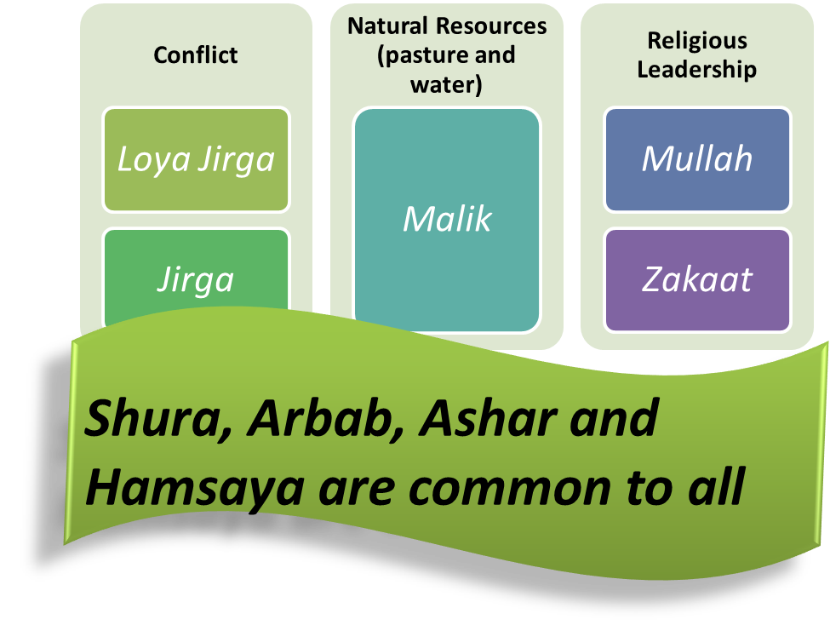

Figure 4: The structure of customary institutions and their mechanisms. Adopted from this research and Schutte (2009) and De Weijer (2002)

This research identified potential interactions between customary and formal institutions that are more of complementary as is the case in *shura* and *jirga* and competing as is the case in *malik* with government structures. Customary institutions interact with formal institutions in four modalities. As can be seen on the table below, these interactions consist of complementary, accommodating, substitutive, and competing modalities (Estrin and Prevezer 2010; Helmke and Levitsky 2004; Lawoti 2010).

Table : A typology of customary institutions

|  |  |  |
| --- | --- | --- |
| Outcome | Effective formal institutions | Ineffective formal institutions |
| Convergence | Complementary | Substitutive |
| Divergence | Accommodating | Competing |

Source: Helmke and Levitsky (2004)

The complementary customary institutions provide “convergence” to the “effective” formal institutions in such a way that the formal institutions could function better. Accommodating customary institutions on the other hand are linked to the effective formal institutions in a different manner thereby trying to alter the meaningful effects of formal rules without creating violence. Substitutive customary institutions are more consistent with ineffective formal rules as opposed to that of the complementary which are related to effective formal rules but they support the ineffective formal rules in confluent manner. Competing customary institutions oppose the “ineffective” formal rules divergently (Estrin and Prevezer 2010; Helmke and Levitsky 2004, Lawoti 2010).

***Shocks/Stressors, Resilience Context and Factors in the Study Area***

As respondents and elites suggested in this study, drought is ranked the first frequent hazard affecting 76% of the population. The hazard ranked second is conflict affecting 65% out of the total population and the third one is livestock disease epidemics (56%). Rangelands conversion and settlement of farmers in the rangelands was prioritized as the forth hazardous factor affecting 53% of the respondents. Most of the pastoralists (51%) are highly vulnerable to the first hazard which is mainly drought whereas 48% of the respondents have medium vulnerability. These shocks and stresses are exacerbated by politicized grazing rights and ethnic identities leading to conflict.

The respondents of this research ranked selling of surplus animals, preparation and use of feed reserves, and diversification/synergy of livelihoods in that order to prepare themselves against shocks and stresses. It has been observed in different studies that the communities support each other prepare against shocks/stresses through customary institutions such as “kinship, clan and tribal interactions, religion (*zakaat*), local codes of honor and customary means” (Schutte 2009) to do these.

As such, this research is consistent with the fact that there are patron-client related customary institutions in Central Afghanistan*.* As explained earlier customary institutions provide decisions in preparing to and responding against shocks and stresses. The comparison of age groups and preparatory activities to increase resilience between now and 15 years ago reflected that there is no statistically significant difference between age groups (p>0.05).

Table 8: Age groups and the strength of customary institutional supports between now and 15 years ago

|  |  |  |  |  |  |  |
| --- | --- | --- | --- | --- | --- | --- |
|  |  | **Observed** |  | **Expected** |  |  |
|  |  | **Weaker** | **No change** | **Weaker** | **No change** | ***P Value*** |
| **Age** | 18-35 | 53 | 18 | 49.65359477 | 21.3464052 |  |
| 36-50 | 36 | 21 | 39.8627451 | 17.1372549 | 0.36 |
| >50 | 18 | 7 | 17.48366013 | 7.51633987 |  |

Chi-Square test

***Roles of Customary Institutions in Building Resilience***

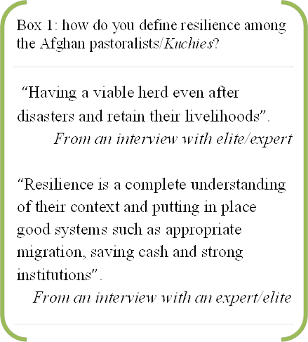Resilience against shocks and stressors for pastoralists in Afghanistan is defined by the elites as the capacity of pastoralists to maintain livestock resources after disasters. Pastoralists are considered resilient against shocks and stresses if they are able to reduce the impacts of livestock diseases, maintain secure places for living after a flooding incidence, put in place strong customary institutions and use saved cash to safely survive in emergency situations. *Kuchies* are resilient if, after shocks and stresses, they are able to reduce the impacts of livestock diseases, maintain security after a flooding incidence, put in place strong customary institutions and use saved cash to safely survive. At household levels, 73% of the pastoralists maintain their families without anyone migrating to urban areas in search of labor whereas at village levels a 82% reported a peaceful coexistence between the pastoralists indicates resilience.

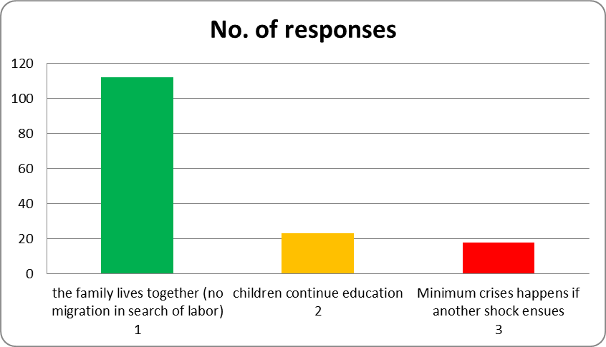

Figure 6: Indicators of resilience at household level after any shock or stressor

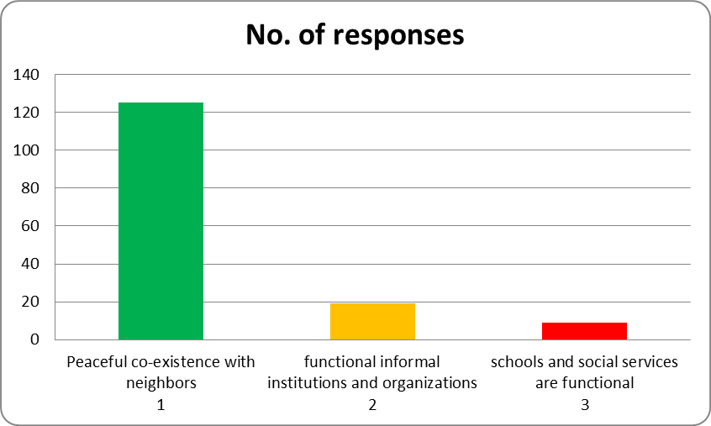

Figure 7: Indicators of resilience at village level after any shock or stressor

Bonjunes *et al*. (2013) stated that resilience aims to understand the systemic shocks and stressors that people are exposed to, and the mechanisms present in their community to withstand them. Resilience is a situation in which a particular community prepares against disasters and mitigates shocks and stresses they may face before, during, and after the strikes (The Global Resilience Partnership 2015). Marschke and Berkes (2006) claimed that resilience is a future oriented tool that offers a lens with which one explores stresses and shocks and understands livelihood trajectories. They further characterized resilience as a system’s ability to deal with changes. The competence of *kuchies*/pastoralists to ‘learn and adapt to live with changes and uncertainties’ is one of the proves of resilience to mitigate the impacts of conflict and other shocks or stresses in this study.

About 75% of the respondents pointed out that the presence of ‘efficient customary institutions’ is the key to make pastoralists become resilient against drought while for conflict, 95% indicated that ‘learning and adaptation to live with changes and uncertainties’ is an indicator of resilience. Continuing to have their livestock and maintaining pastoralist way of life indicate resilience against disease epidemics among 72% of the respondents and developing barriers and/or being able to live on the top side of a swamped area indicate resilience against flooding among 93% of the respondents.

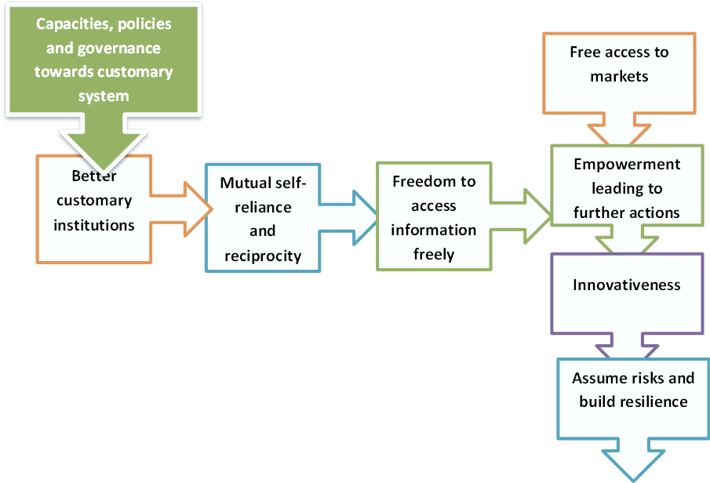

Figure 10:customary institutions and their roles in innovation and resilience. Adopted from the statement of Baival (2012) and Folke *et al*. (2002).

These findings are consistent with the principles of resilience as written by Baival (2012) and Folke *et al*. (2002). The combination of each of the three strategies against drought and conflict above could lead to more resilient outcomes ultimately leading to innovation and growth (Folke *et al*. 2002). Williamson (2009) also stressed that “the presence of customary institutions is a strong determinant of development” which makes people to develop in addition to making them resilient against shocks and stresses.

According to this research, one of the biggest customary institutions that contribute towards resilience building is the process of negotiation with sedentary farmers. De Weijer (2002) had also discussed the importance of the social relationships between *kuchies* and sedentary farmers as great sources of resilience. This study enlightened that the customary institutional set up has been getting weaker compared to 15 years ago mainly as a result of interference by government to replace them with formal institutions instead of supporting to make them stronger than their current status. Unfortunately, government regulations, the formal rules and even some of the international organizations still disregard the customary sector as opposed to the decisions in Bonn of Germany and elsewhere (Pejovich 1999; Checchi and Company, Consulting Inc 2005; Christensen 2010). Christensen (2010) has made a clear assessment of the failures of the formal institutions to recognize “*jirga* and *shura* as they are often staffed by less-educated decision makers, with unclear sets of authorities, improper influence by local powers, and perpetuation of norms and practices that are extremely detrimental to women”. It is very obvious that Afghan women are deprived of several of their rights all the way from access to resources, utilization of assets/equipment to control of any input or output in their environment.

In this study, the respondents highlight that ‘introducing microfinance, feed production and natural resources management’; ‘capacity building and empowerment of customary institutions’ and selection of resilient livestock species and breeds are the three strategies that ranked 1st to 3rd in making the pastoralists resilient in the coming decade. Pastoralists in Afghanistan and throughout the world have already started selecting robust livestock species that are resistant to shocks and stresses. This comprises of selection of resistant goats, camels and donkeys instead of cattle and sheep via their customary institutions (Odhiambo 2012; Oseni and Bebe 2011; Oxfam International 2008).

The leveraging of customary institutions in Afghanistan has strong outputs in terms of creating empowered and sustainable reforms (Kantor 2009). Linking these institutions with other formal institutions such as Community Development Councils (CDC) and Women Development Groups could lead to reduction of structural inequalities that obviously are crucial to get rid of poverty in addition to creating the opportunity to become resilient (Roe 2009).

Furthermore, the study has found out that ‘empowering the animal health service sector and better management’; ‘accessibility of rangelands and water resources’; as well as ‘increasing access to market systems for pastoralists’ make them persistently resilient in the future. Resilience leads to better institutions and better institutions lead to resilience. And this interaction leads to increasing opportunities for Afghan pastoralists to gradually strengthen their *malik*, *jirga*, *shura*, elders and other religious institutions to organize and respond to shocks and stresses before, during and after the incidence in a much better way than now.

Rauf (2009) in Pakistan highlighted the importance of customary institutions for being the keys to foster innovation in many aspects. This has been proven through the responses of the current study such as the capacity of 44% of respondents to diversify or alternate their livelihoods, increase their understanding of shocks/stresses and markets or selection of livestock breeds and species that are resistant to the current shocks/stresses. Afghan government and the other stakeholders that involve in resilience building need to explore such prospects and make use of them. Stanfield *et al*. (2010) assessed the importance of use of customary institutional decisions to develop national policies and strategies in rural Afghanistan instead of starting with a policy at higher levels and consultations with the communities to approve it.

It has been proven by scholars such as Kantor (2009) that it is impossible to exclude the roles of the customary institutional systems to bring about lasting differences. This author emphasized that customary institutions are key in creating social ties in cases of credits, micro-credits and food security at large, the absence of which could lead to high vulnerability in Afghanistan. Eelites and experts in the study underscore that the government needs to formulate policies and strategies to develop the customary institutions and their roles in responding to shocks and stresses.

The interviewed pastoralists recommend that all actors in the development of pastoral areas in Afghanistan need to train the communities and the customary institutions in the areas of livestock husbandry and marketing. Looking at the detailed analysis of Afghanistan and its historical backgrounds, customary institutions could not be overlooked to make the country resilient and eventually develop (Brick 2008).

**Conclusions**

This study explores the types and roles of customary institutions, their organizational structure, their activities in responding to shocks and stressors, and their potential characteristics as sources of resilience building in pastoralist communities in the central Afghanistan. Overall, 153 pastoralist household samples and 6 elites/experts responded to semi-structured questionnaire surveys each of them providing some interesting discourse about customary institutions.

Nearly all respondents agree that *kuchi* leaders, mainly *maliks* are the main players in managing water and rangelands; *jirga* in conflict management; *kuchi shura* in maintaining the rules, customs, norms and believes; and a system of doing things together called *ashar* among pastoralists. The process of assistance to pastoralists in response to shocks and stresses such as moving together to grazing land, provision of stored feed especially during winter, payment for emergency veterinary services, helping in the value chains of livestock, constructing protection walls in cases of flooding, and reporting to the parliament or politicians as final resorts are all parts of the roles of customary institutions. They also play the role of encouraging the communities to take cautionary actions such as leaving the affected areas and promoting the people to help each other.

Interviewed pastoralists prioritized borrowing some money, encouraging the government or people to help, searching for occasional labor work and/or selling of animals for later replacement in that order are the approaches that help survive and build their livelihoods during stresses and shocks. These are all organized and managed by the customary systems within the communities.

Pastoralists are considered resilient against shocks/stresses if they are able to reduce the impacts of livestock diseases, maintain secure places for living after a flooding incidence, put in place strong customary institutions and use saved cash to safely survive in emergency situation. Preparations against hazards to build resilience is displayed by survival of pastoralists together without migrating for search of labor outside of their neighborhood at household levels and peaceful coexistence of pastoralists at village levels. Of the interviewed pastoralists, 75% agree that an efficient local institution to manage rangelands, mobility and negotiation with sedentary farmers is the first thing to be done to enhance resilience against drought. On the other hand, resilience against conflict is augmented by learning and adaptation to live with changes and uncertainties.

Resilience at the end of a shock due to livestock diseases epidemics is characterized by pastoralists being able to maintain their livestock, continuing to treat and vaccinate their animals and continue life as *kuchi*/pastoralist. Pastoralists in general negotiate with sedentary farmers through their customary institutions to get better access to the grazing land of farmers while also benefiting the farmers through for example provision of milk. However, the current set up of customary institutions is weaker than its capacities before 15 years mainly due to the fact that government is struggling to replace them with the formal institutions.

As we move forward, resilience of pastoralists in the central Afghanistan will improve if all actors including government incorporate policies and strategies to empower customary institutions to create and develop microfinances, natural resources management and selection of resilient livestock species and breeds. Moreover, it has been advocated that all actors need to target addressing access to quality animal health, marketing systems and conflict management through engagement of customary institutions at regional, provincial, district and village levels. The customary institutions could then be advocated to become parts of the formal institutional set up most importantly providing complementary mechanisms of development. This way, the customary institutions can gradually be parts and parcels of the policy processes at provincial and country levels.

**Acknowledgement**

The support received from the team of experts of Dutch Committee for Afghanistan (DCA) in collecting the data from the field is much appreciated. My gratitude also goes out to Dr. Gerard Downes for his invaluable and constructive guidance while performing this research.

**References**

1. Baival, B. (2012) *Community-based rangeland management and social ecological resilience of rural Mongolian communities*, Unpublished PhD Thesis, Fort Colin: Colorado State University.
2. Brick, J. (2008) *The Political Economy of Customary Village Organizations in Rural Afghanistan*, Department of Political Science University of Wisconsin, Madison: USA.
3. Bujones, A. K., Jaskiewicz, K., Linakis, L. and McGirr, M. (2013) *A Framework for Analyzing Resilience in Fragile and Conflict-Affected Situations*, New York: Columbia University SIPA 2013.
4. Central Statistical Organization (2006) *Afghanistan Statistical Year Book 2005-2006,* CSO: Kabul [online], available at: <http://cso.gov.af/Content/> [accessed 08 Jun 2015].
5. De Weijer (2002) Pastoralist vulnerability study, *AFSU / VAM Unit of World Food Programme* [online], available at: <ftp://ftp.fao.org/country/afghanistan/kuchi.pdf> [accessed 23 Nov 2013].
6. De Weijer F., (2005) Towards a pastoralist support strategy, *USAID Background Document* [online], available at: <http://pdf.usaid.gov/pdf_docs/PNADG965.pdf> [accessed 27 May 2015].
7. De Weijer, F. (2007) ‘Afghanistan *Kuchi* pastoralists: changes and adaptations’, *Nomadic People*, 11(1), 9-37.
8. De Weijer, F. (2013) ‘A capable state in Afghanistan: A building without a foundation?’ *WIDER Working Paper*, No. 2013/063, ISBN 978-92-9230-640-3.
9. Desta, S. (2009) ‘Risk management strategy for *Kuchi* herders in Afghanistan’, *PEACE Project*, [online], available: [accessed 14 Nov 2013].
10. Elemo, I. A. (2006) *Socio-cultural factors affecting sexual & reproductive health: the roles of traditional institutions among the Borana pastoralists of Oromiya*, Unpublished MA Thesis, Addis Ababa University Faculty of Medicine.
11. Estrin, S. and Prevezer, M. (2010) ‘The Role of Informal Institutions in Corporate Governance: Brazil, Russia, India and China Compared’, *Asia Pacific Journal of Management*, 28(1) [online], available: <http://link.springer.com/article/10.1007%2Fs10490-010-9229-1> [accessed 07 Jun 2015].
12. Helmke, G. and Levitsky, S. (2004) ‘Informal institutions and comparative politics: a research agenda’, *Perspectives on Politics*, 2(4), 725-40.
13. Kantor, P. (2009) Understanding Informal Institutions in Afghanistan, *Middle East Institute*[online], available: <http://www.mei.edu/content/understanding-informal-institutions-afghanistan> [accessed 16 Nov 2013].
14. Lawoti, M. (2010) ‘Informal Institutions and Exclusion in Democratic Nepal,’ Himalaya, the Journal of the Association for Nepal and Himalayan Studies: 28(1),   
    Available at: <http://digitalcommons.macalester.edu/himalaya/vol28/iss1/2> [accessed 07 Jun 2015].
15. Marschke, M. J., and Berkes, F. (2006) ‘Exploring strategies that build livelihood resilience: a case from Cambodia’, *Ecology and Society* [online], 11(2):42 available: <http://www.ecologyandsociety.org/vol11/iss1/art42/> [accessed 20 Oct 2013].
16. Nori, M., Taylor, M. and Sensi, A. (2008) ‘Browsing on fences: Pastoral land rights, livelihoods and adaptation to climate change’, *iied Issue Paper No. 148*, Nottingham: Russell Press.
17. Odhiambo, M. O. (2012*)* impact of conflict on pastoral communities’ resilience in the horn of africa: case studies from ethiopia, kenya and Uganda, *Reconcile/FAO* [online], available at: [www.alnap.org/pool/files/full-doc-28.**pdf**](http://www.alnap.org/pool/files/full-doc-28.pdf) [accessed 01 Jun 2015]**.**
18. Orris, G.J. and Bliss, J.D. (2002) ‘Mines and Mineral Occurrences of Afghanistan,’ *United States Geological Survey Open-File Report 02-110* [online], available at: <http://www.mindat.org/maps.php?id=227441> [accessed 05 Jun 2015].
19. Oseni, S. O. and Bebe, B. O. (2011) *Animal adaptive characteristics and herders’ perception of adaptation to climate variability in pastoral systems in arid Kenya* [online], Available at: <http://start.org/download/accfp/oseni-final.pdf> [accessed 01 Jun 2015].
20. Oxfam International (2008) Survival of the fittest: Pastoralism and climate change in East Africa*, Oxfam Briefing Paper’* [online], available at: <https://www.oxfam.org/sites/www.oxfam.org/files/bp116-pastoralism-climate-change-eafrica-0808.pdf> [accessed 01 Jun 2015].
21. Robinson, L.W. (2009) *Participatory Development and the Capacity of Gabra Pastoralist Communities to Influence Resilience*, unpublished PhD thesis, Winnipeg: University of Manitoba.
22. Sallu, S. M., Twyman, C.and Stringer, L.C. (2010) ‘Resilient or vulnerable livelihoods? Assessing livelihood dynamics and trajectories in rural Botswana’, *Ecology and Society,* 15(4) [online], available: <http://www.ecologyandsociety.org/vol15/iss4/art3/> [accessed 10 Oct 2013].
23. Saltmarshe, D. and Medhi, A. (2011) **‘**Local Governance in Afghanistan: A View from the Ground’, *Afghanistan Research and Evaluation Unit Synthesis Paper* [online], available: <http://www.areu.org.af/Uploads/EditionPdfs/1114E%20Local%20Governance%20in%20Afghanistan%20SP%202011.pdf> [accessed 6 Oct 2013]*.*
24. Schutte, S. (2009) ‘Informal (In)security in Urban Afghanistan’, *Iranian studies*, 42(3), 465-91.
25. Shaumarov, M. and Birner, R. (2013) ‘Dryland Pastoral Systems in Transition: What are the Options for Institutional Change in Uzbekistan?’ paper presented at *How much market and how much regulation does sustainable agricultural development need?* 53rd Annual Conference of the German Society of Economic and Social Sciences in Agriculture, Berlin, 25-27 Sept 2013.
26. Tepper, R. (2008) ‘Who are the *Kuchi*? Nomad self-identities in Afghanistan’, *Journal of the Royal Anthropological Institute (N.S.),* 14*,* 97-116.
27. The Global Resilience Partnership (2015) *this week in resilience: disaster risk reduction*, emailed to Chalachew Agonafir ([chalachewn@gmail.com](mailto:chalachewn@gmail.com)), 27 March [30 March 2015].
28. Walliman, N. (2006) *Social Research Methods*, London: Sage Publications.
29. [Wardak, A. (2003) ‘Jirga – A Traditional Mechanism of Conflict Resolution in Afghanistan](http://unpan1.un.org/intradoc/groups/public/documents/apcity/unpan017434.pdf)’, *United Nations Online Network in Public Administration and Finance* [online], available: <http://unpan1.un.org/intradoc/groups/public/documents/apcity/unpan017434.pdf> [accessed 23 Nov 2013].
30. Yami, M., Vogl, C. and Hauser, M (2011) ‘Informal institutions as mechanisms to address challenges in communal grazing land management in Tigray, Ethiopia’, *International Journal of Sustainable Development & World Ecology*, 18(1), 78-87.

1. Oral discussion with field experts in the regions (Dr. Qader Fakhri, Dr. Faridoon Qayumi and Eng. Haroon Nessar – Kabul Province).